# Durable Furnitures

Knowlton

## Manchester Two-Tone Writing Desk

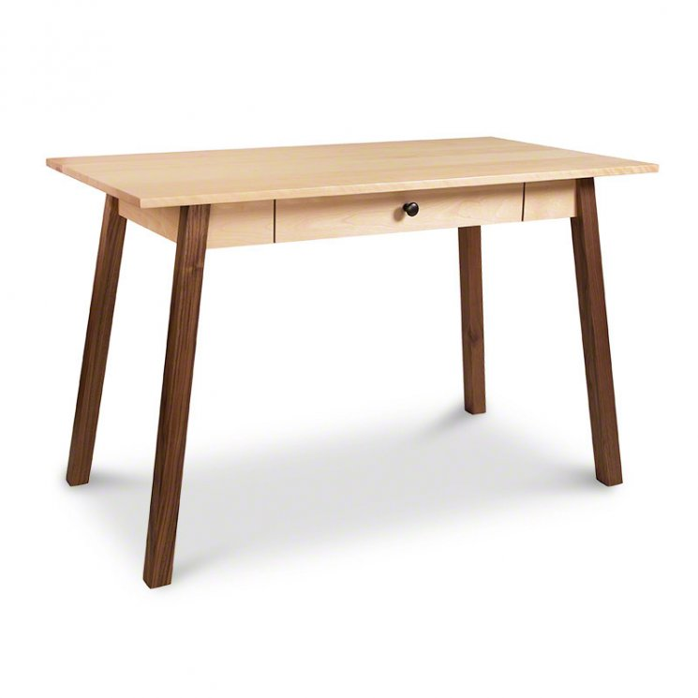

This item is currently in our showroom in Vernon, VT and except in special circumstances will only be available for 'cash and carry' purchase directly from our showroom. Please contact us by phone at 802-579-1302 if you would like to discuss other purchase arrangements.